**Expert - Android App - 11-10-2023**

**- Version - 6**

**Issues are listed below:**

Module - - Sign in

1. Forgot password is not working.
2. Remember me can be checked but functionality is not enabled.
3. On the Enter password page password word is present multiple times.

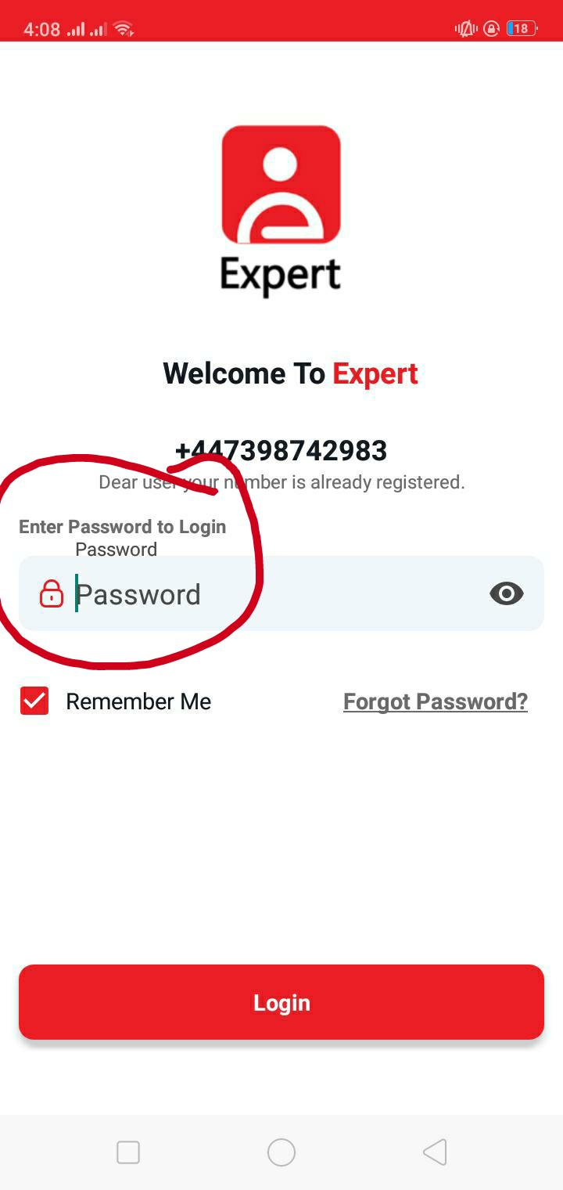

Module - - Home

In the Industry section on home many options have irrelevant images.

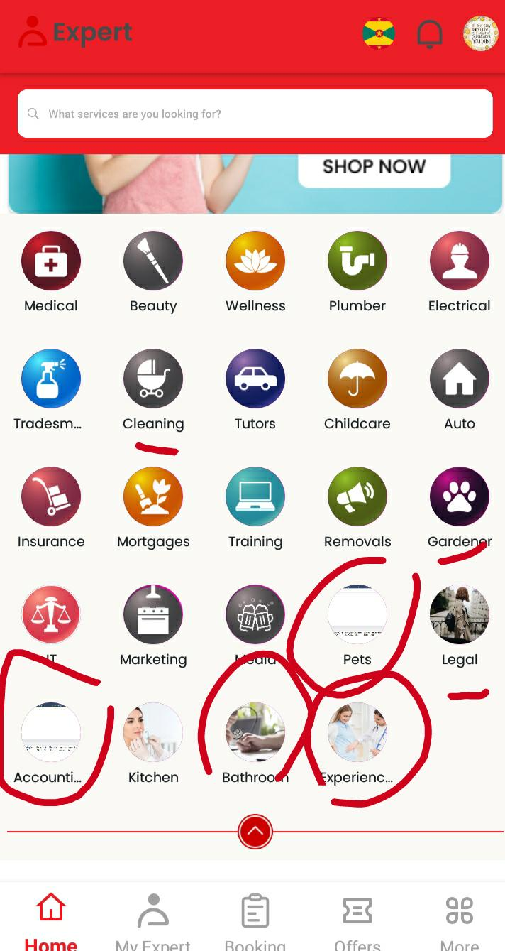

When a user clicks on any available service on the home page and clicks back to the home page it redirects to the top of the app not to the relevant service.

In home Many services have description of image but not connected with image div. Only images that are clickable text aren't.

**Module - - Profile**

1. Secondary Mobile is added by default cant edit.
2. Date of Birth field - - When an under 18 date is added it adds this message in the field it should only show an alert message
3. Gender is not saved. 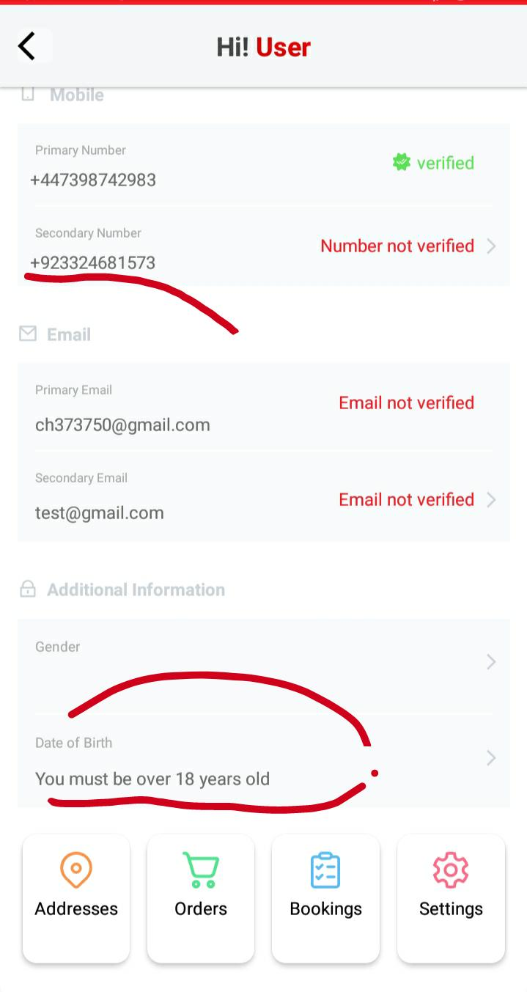
4. By default male radio button is selected it shouldn’t.
5. User clicks on update name (icon present on right side of icon) fields should have already added name but it is empty.
6. In Primary and Secondary email when clicked on add fields are empty it should have already added email.

**Module - - Booking a service from aesthetics**

1. Can’t do any booking.
2. Provider and client (who books a service) do not have the same address but are still booking.
3. Appointment date is not updating as added. May added after sometime.
4. In the booking section add booking notes are present in which images can be uploaded but capture from camera is not supported. Can’t upload video.

**Choose Address - -** In this module a long address is overlapped. Spacing is very less between different Addresses.

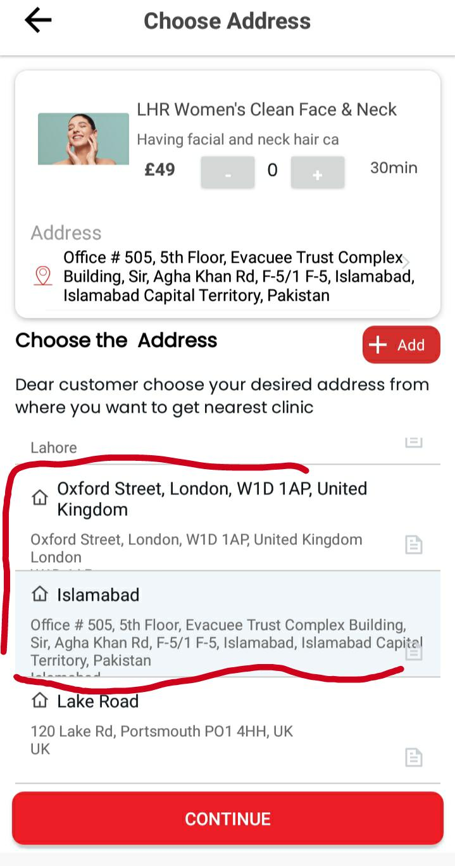

**Module - - Payment**

1. Duplicate cards are created in Add Card.
2. Only UK, or 2 digits can be added.
3. Multiple address fields are present.

After adding payments take the user to verify Payment but do not publish booking.

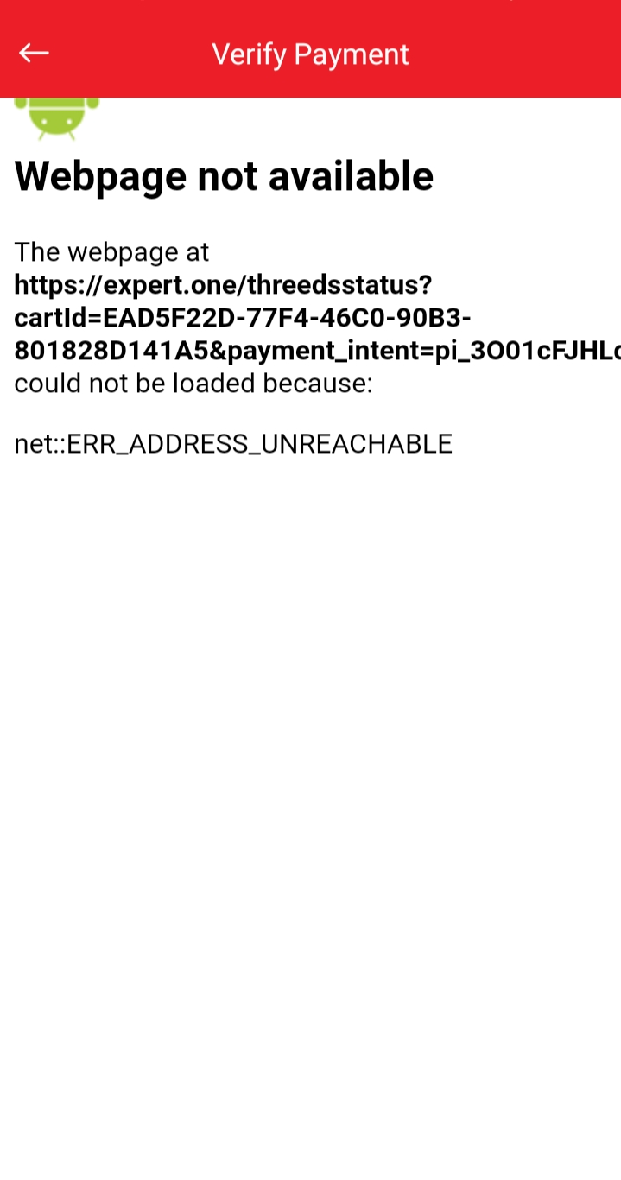

**Booking tab** - - 505 error.

**Module - - Flags**

On the top section flags are present many flags images are wrong these are listed below:

* Australia
* Azerbaijan
* Bahrain
* Cuba